**Association:**

1] An **association** is defined as an organization of people with a common purpose and having a formal structure.  
2] It represents a binary relationship between two objects that describes an activity.

3] Association manages **one-to-one, one-to-many, many-to-one** and **many-to-many** relationships.

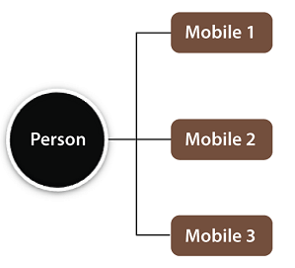

**Fig. Association**

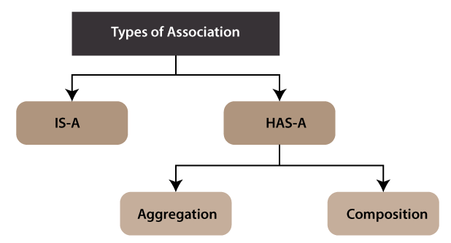

**Fig. Types of Association**

**Aggregation:**  
1] An **aggregation** is a collection, or the gathering of things together.

2] This relationship is represented by a “has a” relationship.

3] Aggregation follows the one-to-one or one-way relationship.

**Composition:** In a composition relationship, the associated objects cannot exist independently within the scope of the system.

|  |  |  |
| --- | --- | --- |
| **Association** | **Aggregation** | **Composition** |
| 1] Represented using an arrow. | Represented by a straight line with an empty diamond at one end. | Represented by a straight line with a black diamond at one end. |
| 2] In UML, it can exist between two or more classes. | It is a part of the association relationship. | It is a part of the aggregation relationship. |
| 3] It can associate one more objects together. | It can associated objects exist independently within the scope of the system. | It can associated objects cannot exist independently within the scope of the system. |
| 4] It incorporates one-to-one, one-to-many, many-to-one, and many-to-many association between the classes. | It exhibits a kind of weak relationship. | It exhibits a strong type of relationship. |
| 5] Objects are linked together. | Linked objects are independent of each other. | Linked objects are dependent on each other. |
| 6] It may or may not affect the other associated element if one element is deleted. | Deleting one element in the aggregation relationship does not affect other associated elements. | It affects the other element if one of its associated element is deleted. |
| 7] Example: A tutor can associate with multiple students, or one student can associate with multiple teachers. | Example: A car needs a wheel for its proper functioning, but it may not require the same wheel. It may function with another wheel as well. | Example: If a file is placed in a folder and that is folder is deleted. The file residing inside that folder will also get deleted at the time of folder deletion. |